CVI620 – Assignment 2
Fall 2025

Total Mark: | 7.5 marks (7.5% of the total course grade)
Submission file(s): | - Python files for train and inference
Deadline | - November 27th, 2025

If you are unable to complete the assignment on-time for any legit reason, please provide documentation explaining your absence (e.g., an appointment confirmation or a work letter).

Please submit the submission file(s) through Learn@Seneca. Make sure to use GitHub and provide the link to your GitHub account for all your contributions in the box below:
Project GitHub repository:

Please attach some of your test images along with any required explanations in this document.

- For the Cat and Dog dataset provided in the Q1 folder, perform classification using all the methods you know and try to achieve the best possible result. Compare the algorithms carefully and tune the parameters so that the best result can be obtained.
Save the trained model and test it on several images from the internet. Was the model able to correctly predict the images?

The model isn't very accurate. Although KNN scored high accuracy during the test data with 70%, it was only able to correctly identify 1 out of 6 of the sample images taken from the internet.

On the other hand, Logistic Regression and Stochastic Gradient Descent were able to correctly identify 4 out of 6 from the sample data even if they only scored 40% in the test data.

Overall, the three models are very inconsistent and so they are not very accurate with their predictions.

Note: Trained models can be found in the models folder but make sure to paste the files to the root folder if not opting to run the model creation file.

Accuracy score from test results:

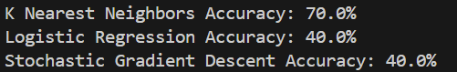

Results for sample images:
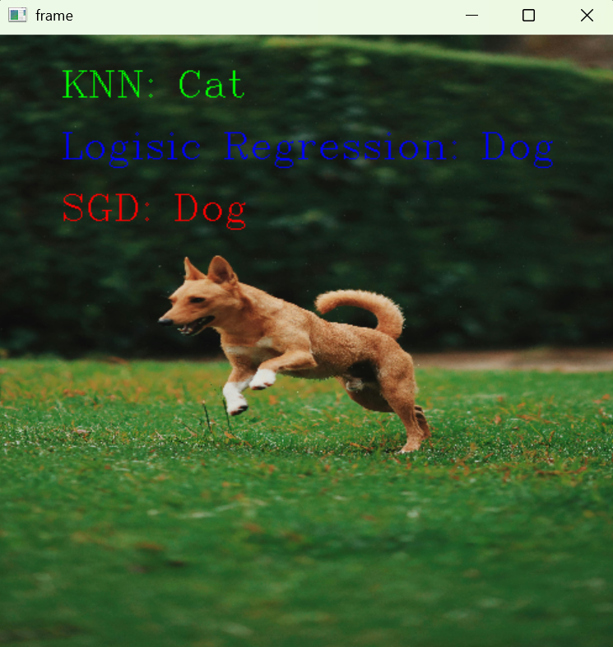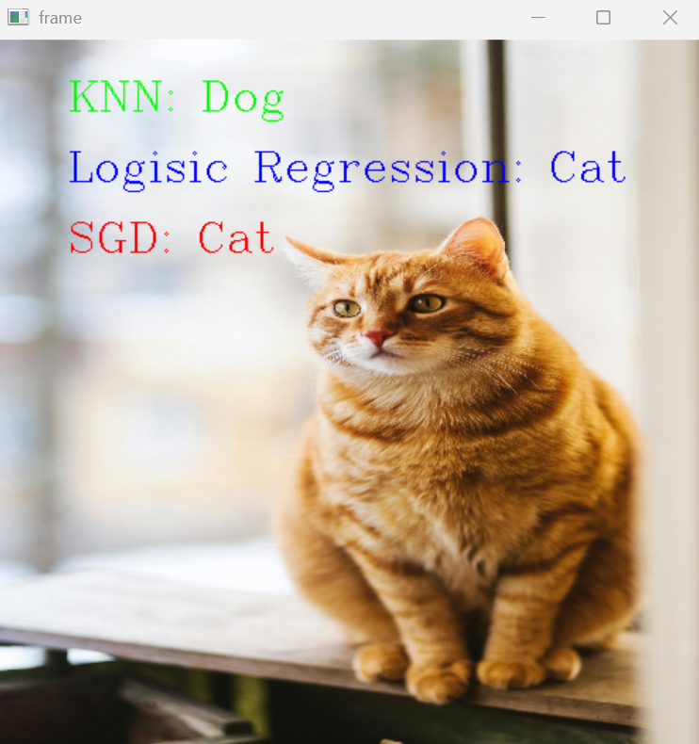
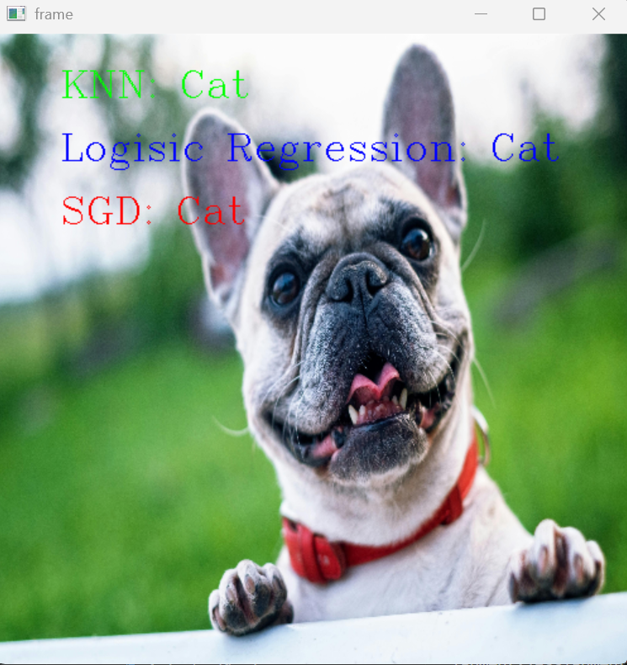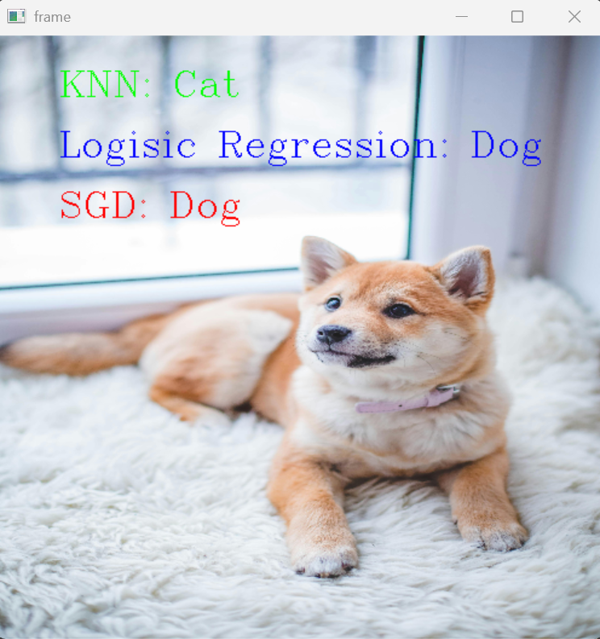
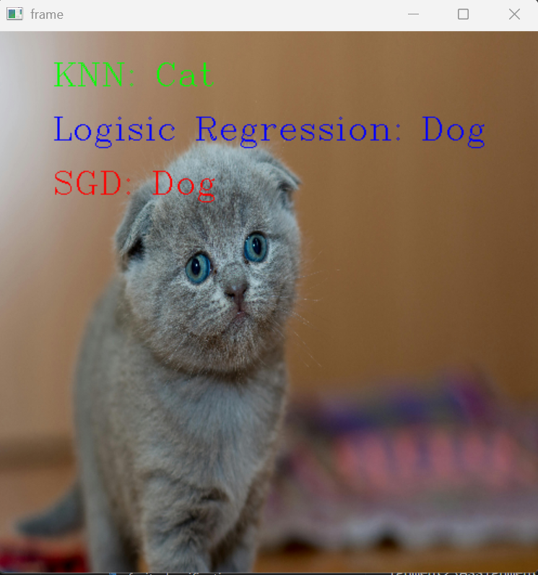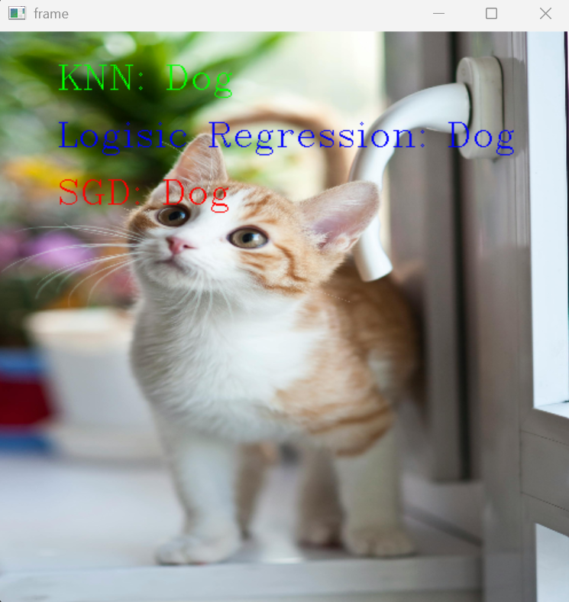

- The MNIST dataset is one of the most well-known datasets in the field of image processing. It contains 60,000 images related to handwritten digits from 0 to 9 and is provided as a CSV file in the Q2 folder. In this file, each image is represented as a flattened vector. Classify this dataset using different methods and try to achieve at least 90% accuracy.

All 60,000 rows in the training csv file were used to train the models. This makes the model creation take a substantial amount of time. However, the trained models can be found in the models folder but make sure to paste the files to the root folder if not opting to run the model creation file.

All 10,000 rows in the testing csv file were used to test for accuracy.

The model yielding the highest accuracy score is the one that uses K Nearest Neighbor with an accuracy of 96.59% from the 10000 test cases provided. The second one with the highest accuracy score is the Logistic Regression, but only by a around 1% above the one that used Stochastic Gradient Descent.

All models have an accuracy score of above 90%.

Accuracy score from test results:

